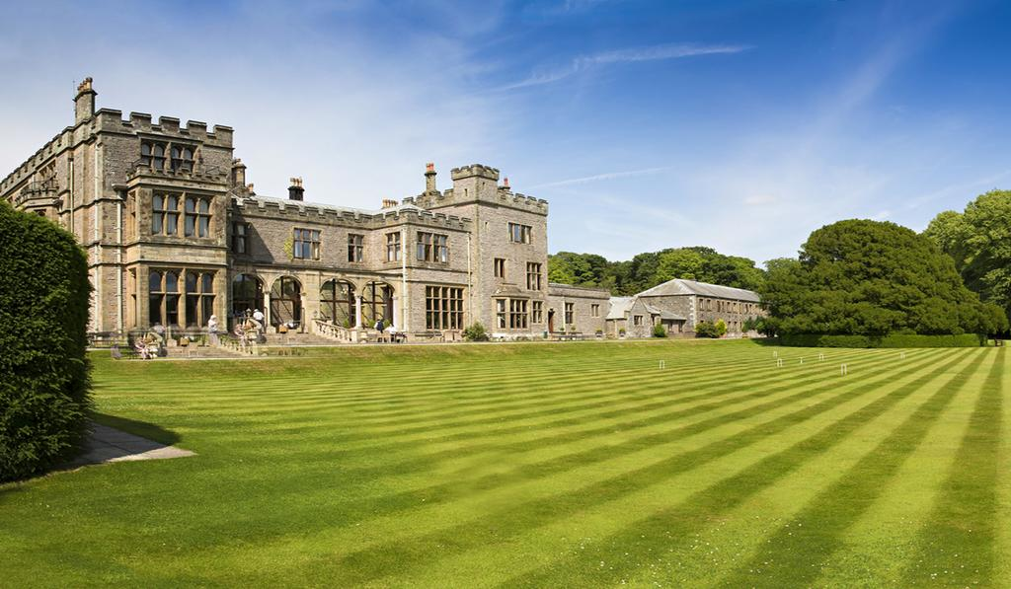Friday 1st May 2020  Annual Dinner  This promises to be another excellent evening at Armathwaite Hall on the shores of Bassenthwaite Lake near Keswick in the heart of the Lake District, thanks to the generous hospitality of the Manager, Simon Steele (FS 85-89).  Do let me know if you are interested as soon as possible as it is likely to get booked up very quickly.  Full details will be posted at a later date although the menu is as over.  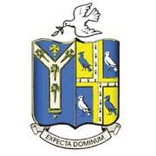 | West Cumbria Branch OSB  ────  Another fantastic night beckons at this world renowned hotel.  ────  Cost is £30.00 per head (normally £40)  ────  B&B including use of spa £150 (normally £220)  ────  Book Early to avoid disappointment  For Reservations  St Beghian Society  Darryl Davies  Darryl.davies1@btopenworld.com

The St Beghian Society
3 course dinner menu - 1st May 2020

Roasted carrot, apple soup, paprika butter
crème fraiche
Or
Crispy king prawns, lime, ginger
Romesco sauce
Or
Ham hock and pistachio roll, apple
Watercress, piccalilli

.oOo.

Roast Cumbrian Beef
Traditional trimmings, Yorkshire pudding
Or
Pan fried Halibut
Pea velouté, heritage carrots, sautéed potatoes
Or
Wild mushroom bourguignon
Buttered mash, stem broccoli

.oOo.

Sticky toffee pudding
Brandy snap, vanilla ice cream
Or
Mixed berry pannacotta
White chocolate truffle
Or
Cumbrian cheese platter
Pickles and crackers

.oOo.

Coffee and mints

If you have any concerns relating to the allergens detailed below please speak to the Restaurant Manager prior to ordering: Cereals containing gluten, crustaceans, eggs, fish, peanuts, soybeans, milk, nuts, celery, mustard, sesame, sulphites, lupin and molluscs

